31. open ILCA 7 ja ILCA 6 Masters championships
Nagu Segelsällskap invites you to Nagu, Finland July 30th – 31st 2022
Regatta Information
Race office is open on Friday 29.7. 19-21pm and Saturday 30.7. 9am.
Skippers meeting in from of race office Saturday 10:15am. Target is to complete 6 races, 3 races per day. First warning signal on Saturday 11:55.
Sauna ja showers after racing. Barbeque evening at 19:00, with daily first prices.
First warning signal on Sunday 10:55.
Right to participate
Entry is allowed to sailors who, by 31 December 2022, are aged as follows. Note: Apprentice – category from age 30.

Classes and categories (age groups):
ILCA 7 (Standard): Apprentice (30-44), Masters (45-54), Grand Masters (55-64).
ILCA 6 (Radial): Apprentice (30-44), Masters (45-54), Grand Masters (55-64), Great Grand Masters, Legends and Ladies.
Minimum age for the age group needs to be reached before 31.12.2022.
Entry
Register your entry before 25.7.2022 at 20:00pm through Manage2Sail

Entry fee 50 euro to be paid to NSS (IBAN: fi89 5560 0940 0015 80, BIC: OKOYFIHH) by 25.7.2022. Late entry fee is 70 euro.

The participant needs to be a member of the National Laser Association in his/hers country.
Every participant is required to have a unique sail number.

Accomodation and miscellaneous
See list of accommodation options below. Book your stay well in advance.
Web site for the race: www.nagusegelsallskap.fi;
Info: Martin Forss (martin.forss@gmail.com) mobile: +358 40 779 6266

Accommodations. Please reserve yours well in advance
Close to race venue | Company | Adress | Phone | epost | www
 | Hotel Stallbacken Nagu | Grännäsvägen 14, Nagu | +358 40 48 66 822 | info@hotelstallbacken.fi | https://www.hotelstallbacken.fi
 | Kirjais Nature Inn & Villas | Sarviksvägen 31, Lillandet | +358 45 698 7477 | camilla@kirjaisnatureinn.com | https://www.kirjaisnatureinn.com/?lang=fi
 | Västergårds | Gyttjavägen 29, Lillandet | +358 50 355 3337 | info@vastergards.fi | https://www.vastergards.fi/contact/
Yes | Hotel Strandbo | Nagu strand, Nagu | +358 20 733 2020 | myynti@strandbo.fi | http://www.strandbo.fi/hotel-strandbo.html
Yes | Hotel Lanterna | Parkvägen 5, Nagu | +358 40 755 1419 | info@lanterna.ws | https://www.lanterna.ws/fi/
 | Villa Vintage | Käldingevägen 1, Nagu | +358 50 5764477 | https://villavintage.fi/pages/kontakta-oss | https://villavintage.fi/pages/loppis-kirppis
Yes | Köpmans | Strandstigen 3, Nagu | +358 40 643 4430 | info@kopmans.fi | https://kopmans.fi
Yes | Majatalo Martta | Kyrkvallen 6, Nagu | +358 40 648 6302 | uja.aili@gmail.com | http://www.majatalomartta.fi
 | Tackork Gård&Marina | Tackorkvägen 31, Nagu | +358 45 78747461 | info@tackork.fi | https://tackork.fi
 | Gammelgård Resort | Norrstrandsvägen 217, Nagu | +358 41 314 3800 | info@gammelgard.fi | https://gammelgard.fi
 | Finlands Skärgårdsbokning | BOKNINGSTJÄNST / VARAUSPALVELU | +358 2 410 6600 | info@saaristovaraus.fi | https://saaristovaraus.fi
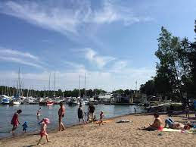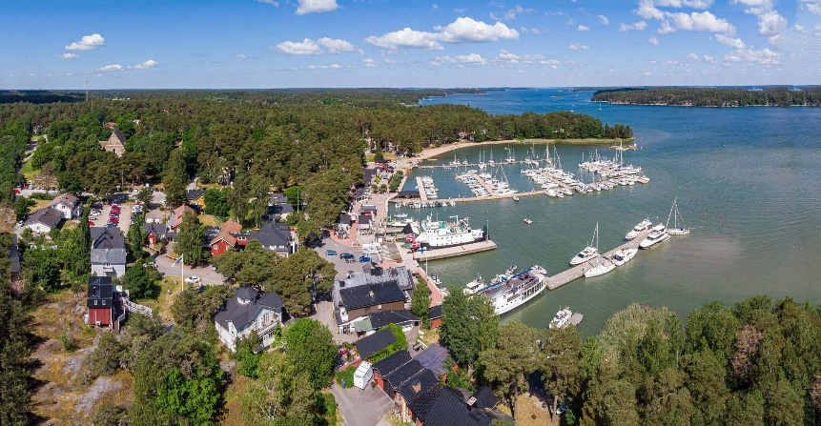
WELCOME TO THE MOST BEAUTIFUL PART OF FINLAND
(Nagu | Visit Pargas (visitparainen.fi))

